

CELEBRATING ITS 59TH YEAR
The Game Fair comes to Hatfield House, Hertfordshire for the First time in history, 28-30 July 2017.

INFORMATION FOR LOCAL RESIDENTS

Since 1958, The Game Fair has entertained, educated and inspired generations who attend the prestigious event to shop, meet with friends, swop ideas, share news and innovations. Next month the event will be held at Hatfield House and experts predict 120,000 visitors could attend.

PLANNING

The Game Fair is a large and complex event which is managed by 20 full time professionals with offices here in Hatfield. A number of special measures for residents have been put in place and broader plans have been agreed with the local authority and road and traffic agencies. This document outlines some points of reference which you may find useful.

SPECIAL LOCAL RESIDENTS BENEFITS

Organisers of The Game Fair have set aside 500 complimentary tickets for each day of the event. Applicants can secure up to two complimentary tickets per household by following this simply on-line procedure. Tickets are valid for one day only.
- Visit www.thegamefair.org
- Click on buy tickets (you will not have to buy them)
- Enter code XXXX in the promotional code box (this is your unique code and can only be used once)

For residents that cannot access on-line or who experience difficulties, additional complimentary tickets will be held at Station Lodge. Evidence of a recent utility bill and photographic identification such as a driving license is all you will require.

Parking: Parking is free at The Game Fair. However, we recommend that you walk to the event if you can to avoid queues and possible delays. A full map is displayed on the following pages although pedestrians should access the event via Station Lodge [Entrance B] which is opposite Hatfield railway station. Make sure you have secured on-line tickets before you attend.

Vehicle identification passes: Residents within Old Hatfield will be issued with identification passes to be displayed in vehicle windscreens. This will help officials and traffic officers to identify legitimate local traffic wishing to access and exit Hatfield Old Town. Clearly display the passes at all times although traffic intervention will only take place if congestion or traffic flow strategies need to be implemented. Any additional passes will need to be collected from Station Lodge (please bring ID and proof of address). No road closures are anticipated.

ADVICE FOR FRIENDS AND RELATIVES

If you are planning to invite friends or relatives to attend The Game Fair with you, whilst normal tickets can be purchased on the day, we recommend that they secure advance discounted tickets in advance. Tickets can be purchased at www.thegamefair.org.

WE STRONGLY RECOMMEND THAT FRIENDS AND RELATIVES DO NOT FOLLOW FAMILIAR ROAD ROUTES OR SATELITE NAVIGATION INSTRUCTIONS. INSTEAD ALL TRAFFIC SHOULD FOLLOW AA SIGNS AND DIRECTIONS. PARKING IS FREE AND VEHICLES SHOULD PARK IN THE DESIGNATED CAR PARKS WHICH ARE DETAILED IN THIS DOCUMENT.

GATE OPENING TIMES WEBSITE INFORMATION

Friday 6am – 7.30pm www.thegamefair.org
Saturday 6am – 6pm email:info@thegamefair.org
Sunday 6am – 6pm Dogs are welcome

TRAVELING BY TRAIN

There is an excellent train service from London Kings Cross and from Cambridge with trains stopping at Hatfield Station directly opposite to the Hatfield House Estate, Station Lodge Entrance.

THE SHOW LAYOUT

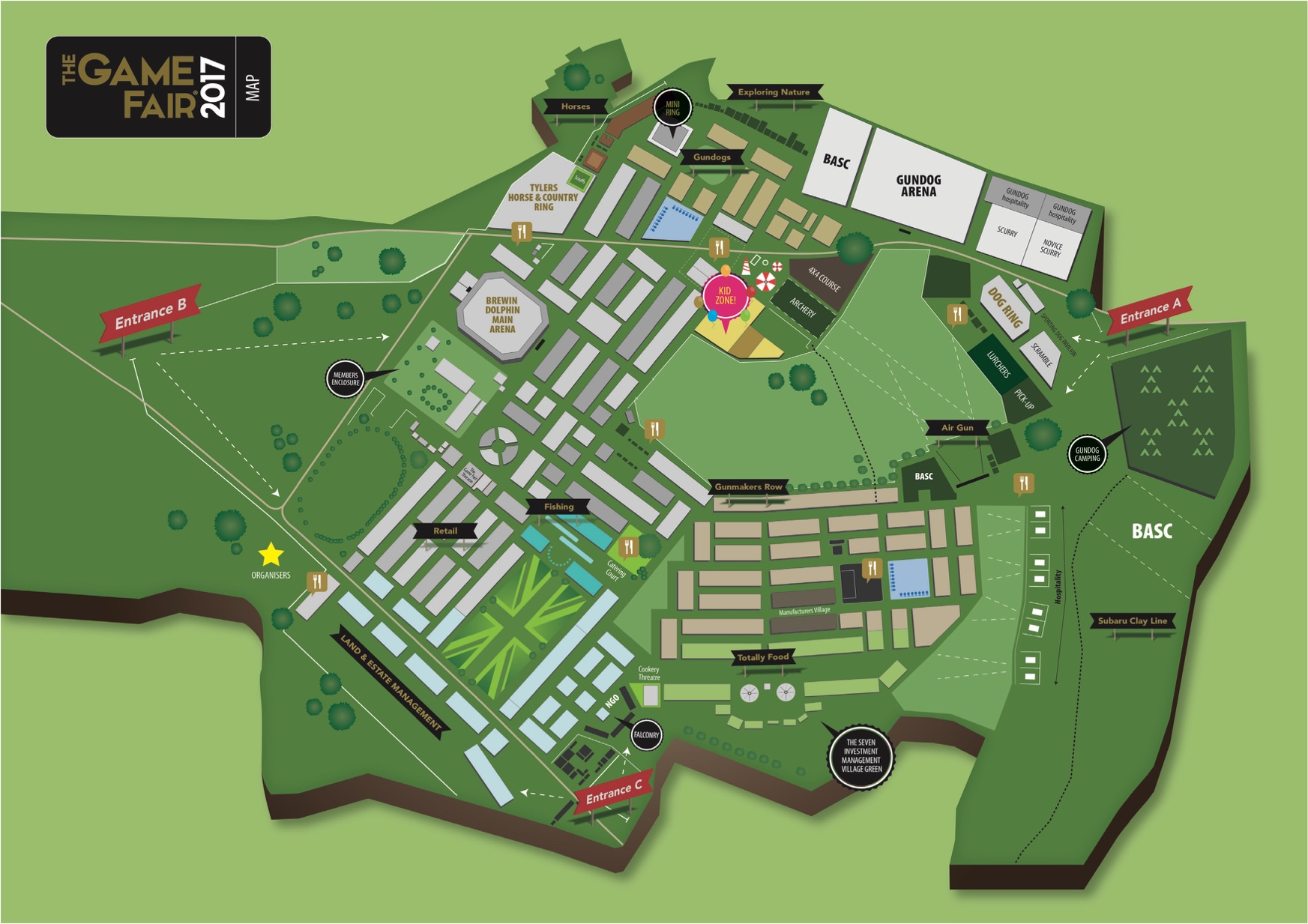

Entrance B is best for those arriving by train, local residents and pedestrians.
Entrance C is best for people driving from London or the south. Parking will be accessed near Welham Green shown in the map below.
Entrance A is best for people travelling from the North or East travelling south. This entrance and carpark will access mainly along the A414 travel East to West through what is locally known as ‘Saw Mills’ entrance. This is also the best entrance for visitors who have booked camping and who are staying on site.

FAQ

Q How many visitors are expected to attend? | A If the weather is nice, official expect around 120,000 visitors across 3 days or 40,000 visitors each day.
Q Will visitors all arrive at the same time? | A Visitors will arrive over a long period of time between 6AM and 11am usually and start to depart the estate site from 4PM until 6:30PM so traffic can disperse in an orderly fashion.
Q How many exhibitors will there be? | A It is expected that there will be around 800 exhibitors
Q Is there any live music? | A There will not be any amplified music and certainly no ‘concert style’ entertainment.
Q Why is the event going to be at Hatfield House? | A The Hatfield House estate is one of only a few prestigious English estates that can accommodate The Game Fair. In the past the event has been held in other historic locations such as Blenheim Palace and Ragley Hall. The event is estimated to bring benefit of £30m to the local economy with Hotels, The University, Restaurants, Attractions, shops, services and local businesses amongst those benefiting.

FOR ANY EMERGENCY DURING THE EVENT PLEASE CONTACT
01707 830342

