Old Hatfield Zone B01 parking CDG draft rev 1 27th June 2017

Background and current situation
In 2008 there were approximately 300 homes and 500 residents in the area shown in Fig 1 below, plus commercial and retail operations. These were supported by three types of car parking:
- Private areas, including private garages and drives, the Jobcentre car park, private bits of the public car parks, the area near George’s Gate (pink)
- On-street parking for Zone B01, shown as blue lines
- Public Car Parks (yellow)

The GCE plan of 2008, around the time of the Charrette, involves substantial redevelopment, notably the construction of a 2-storey car park within the area of the current Salisbury Square Car Park. The general layout is shown in the 2014 Design and Access Statement in Fig 2

The 2008 plan had envisaged an increase in parking provision in the 2-storey park as shown in the table below.

Use | Existing (2008) | 2-storey provision plan
Residential | 0 | 26
Commercial units | 0 | 21
Public parking (2 hr) | 65 | 50
Private parking | 13 | 13
Job Centre | 31 | 31
Total | 109 | 144

Developments since 2008, especially since 2014, and those in the pipeline have substantially changed the demand for parking. Some of these developments are listed below.

The management of the existing public car parks is totally inadequate*, the promised survey of on-street parking is again delayed, and there is no timescale for the agreed transfer of ownership of the remaining 50% of Salisbury Square from WHBC to GCE. It is not clear where responsibility for managing the new 2-storey car park will lie, or what criteria WHBC will apply in issuing parking permits in the future.

Old Hatfield Residents’ Association Proposal
The OHRA asks that in the short term, until WHBC and GCE have developed a plan to manage parking in Old Hatfield, only car-free developments are approved. Residents’ parking permits and permits to park in the public car parks should only be issued to those with existing homes and businesses.

WHBC should maintain a published register of the number of permits issued by address and business, so that the fairness of their allocation is transparent.

Some thought should also be given to the medium term arrangements that will apply while the new 2-storey car park is being constructed

Developments since 2008
A) Marychurch Square. Residents objected to the 2008 plan on the grounds that it significantly reduced the green space in Old Hatfield. GCE undertook to amend the plans for “Marychurch Square” by turning the car park to grass. This would involve re-siting the existing car parking to avoid loss of parking for retail units on the parade, and re-siting of the private area of the Car Park

B) AL Marketing. This development of 19 flats included 6 built on the Car Park. Residents can apply for parking permits

C) Willow Building. This development of 5 flats replaces the previous commercial occupation which in 2008 had 40 cars registered to park in the public car parks

Current planned developments
It is noted that WHBC has very limited planning powers in relation to conversions from commercial to residential (apparently the council can insist on bike parking provision, but not car parking provision). We have asked WHBC to look into implementing “Section 4” legislation as a means of overcoming this problem, but they have not been responsive, and time is not on our side.

D) Jaipur development. This application for was called in, and it is hoped that the developer will re-apply for a car-free development

E) 52/54 Great North Road. 6 flats. To be called in, we hope, as it allocates car parking space that may currently be used by B07 Arm & Sword Lane residents, which could result in them applying for B01 residents’ permits. OHRA objected to creation of B07 on the ground that developers should not be allowed to ring-fence part of the limited Old Hatfield parking for their developments. Parking aspirations for homes on the other side of Arm & Sword Lane are unknown.
As at 27th June we understand that the application has been withdrawn, primarily on the grounds that the space per flat is too small, but we also understand that the current Arm & Sword residents are sure that the parking space behind 52/54 is theirs.

F) Checkers (aka Chequers). Application for conversion to flats expected.

G) Job Centre. Lease expires March 31 2018. Application for creation of 16 flats on 1st and 2nd floors. Reallocates 36 spaces as 16 for flats and 20 for Job Centre. This application could affect the access route from the station to Salisbury Square.
As at 27th June we have been reassured by Templewood Securities (the freeholder) that they support the Hatfield House plan, and that they expect to do a land swap to allow direct access from the station to the Square. We are however registering two concerns: the large number and small size of the flats, and the parking implications.

Developments outside B01
A large number of flats have been created on the west side of the A1000. These are outside B01, and should not be allowed permits in either B01 or B03. The on-street residents parking zone restrictions will need to be amended to reflect the pressure that can be expected from visitors to these new developments as well as from commuters.
The developments proposed between WGC and Hatfield will also increase pressure on parking near the station, and the capacity of the multi-storey station car park is finite (380 spaces)

‘* some 600 permits to park in the public car parks have been issued, but there is apparently no record of the organisations to which they have been issued, and the ANBS system that should penalise those without permits is not in use. Around 150 residents permits to park in the public car parks have been issued. The total capacity of the 4 current car parks is 119.
Fig 1 Map of Old Hatfield ca 2014 (no Arm & Sword Lane) showing 4 main car parks with number of spaces and recent / planned developments (lettered A to G)
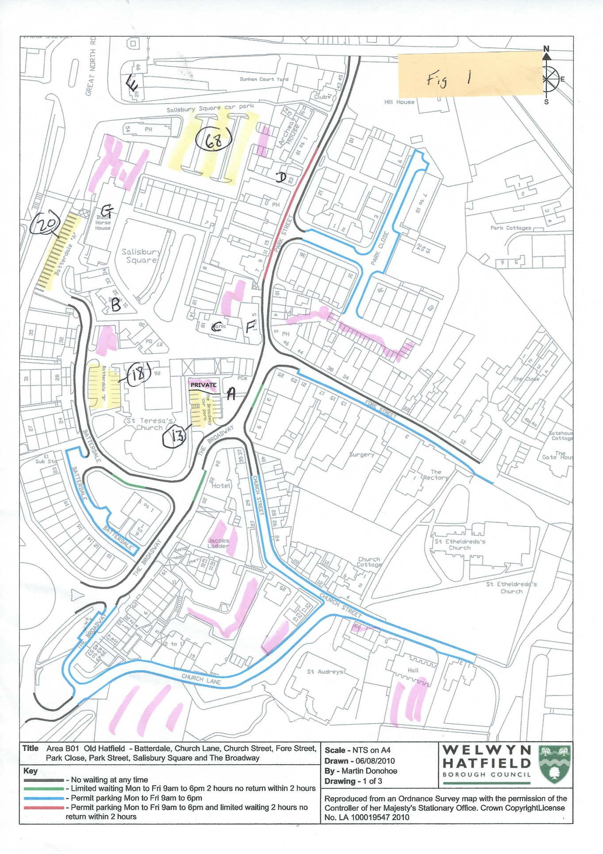

Fig 2 Salisbury Square Car Parking Layout
Design and access statement Henshall Green for GCE June 2014
