

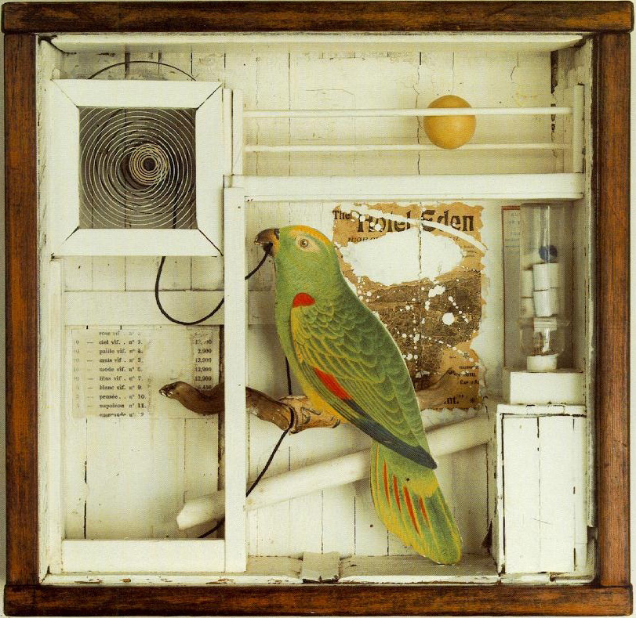

Joseph Cornell, L’Hôtel Eden, 1945

Old Hatfield
Building an Archive

Architectural Design Studio 1

Module code: 4CTA1199
Semester A+B – Week 09 - 42
Credits: 30

Design Skills 1

Module code: 4CTA1198
Semester A+B – Week 09 - 42
Credits: 30

Module Leader: Silvio Carta (s.carta@herts.ac.uk)

Module tutors:
Alvaro Velasco (a.velasco-perez@herts.ac.uk)
Elena Palacios (email to be confirmed)
Sabrina Puddu (s.puddu@herts.ac.uk)
1. Module(s) Introduction
Architectural Design Studio 1
The role and importance of the context in architecture is crucial for a consistent and logical development of a design proposal. This module allows students to understand and explore means of representing observations, explorations and proposals. Within the observatory work, students will make a coherent set of drawings of their own architectural explorations at a range of scales including 1:100, 1:200, 1:500, 1:1000, 1:2000, 1:5000 where appropriate. The explorations and propositions will be drawn in plan, section, and elevation, in model and in three dimensions, at various scales. The students will elucidate the proposed strategy, programme, context, and position through these representations. The main outcome of this module is a design proposal where the relationship with the context and the urban environment are explicitly illustrated and logically substantiated.
This module will provide students with an understanding of the different aspects and complexities related to building design at different scales. The activities of this module allow students to familiarise themselves with design projects of diverse scale and complexity and require them to consider the brief from different angles. The outcome of this module is the development of a design proposal where the conceptual and critical approach to the given site is explicit and substantiated through analysis and relationships between the different scales. The final proposal should integrate aesthetic aspects, the public use of space and the technical requirements of the scheme both at the scale of the building and the one of the city.

Design Skills 1
This module aims at using and developing manual drafting and CAD skills or other media to assist in the visual communication and presentation of design ideas. Various forms of 2D and 3D manual and digital representation and development are explored. Students explore design ideas through manual and digital design methodologies to realise a series of defined projects during supported workshops and directed study time. Assignments are designed to support Design Studio modules.
The module purposefully includes a range of manual and software activities that approach design in different ways and which develop a variety of learning tools. This encourages the student to develop a wide range of visual communication skills. It also requires students to become familiar with the transfer of files between applications and often, between platforms. Students learn to apply a design process which includes critical appraisal of briefings, visual and factual research, speculation on potential solutions, selecting and synthesizing innovative ideas, developing preferred outcomes and refining and presenting ideas to an informed audience.
The taught content of the module is through lectures, seminars, practical demonstrations, tutorials and workshop sessions. Students are expected to complete directed study assignments in set times (often before the next lecture / demonstration).

2. Module(s) structure
Module Guides – Further essential information
Please refer to the Module Guides for modules 4CTA1199 – Architecture Design Studio 1 and 4CTA1198 – Design Skills 1, located on the StudyNet – Canvas pages, under the section ‘Module Information’ and ‘Module Specific Requirements’ to learn more about:
- Learning Outcomes
- Assessment procedures
- Important dates, etc.
This Project Brief is related to two (2) Modules intended to complement each other. Each student is assigned to a Studio, which will be a student group lead by one tutor, to carry out Project 1, Project 2 and Project 3 in Sem. A. and Sem. B during the entire academic year.
The Studio and the activities related to it are built upon four guiding questions:
Practical (tools for design)
Part of the sessions will be dedicated to applied techniques and methods related to the implementation of the design ideas. It is considered crucial for a designer to be able to confer ideas a physical form.
Analytical
Parts of the sessions are oriented to the self-criticism and the understanding of your own work.
Referential
It is crucial for a designer to be able to position him/herself towards the arena of contemporary design and the other (existing) projects in his/her field of work. Part of the activities in the Studio will be dedicated to the analysis and debate of case studies in order to position each project within a larger framework of work.
Communicative
The project benefits enormously from its clear and sharp communication. Where possible, part of this module will be developed along with the Communication modules.
Project Activities:
Site Visit:
You will measure and analyse the existing building directly on site, understanding the physical characteristic of the site, their function and use, and learning how to generate a clear set of drawings of the existing situation.
Studio Work and Tutorials
You will work both independently and with the tutor(s) in order to practically develop the project (concept, drawings, models, images etc.).
Seminars
The tutors will lead classroom activities such as case studies and group discussion to facilitate your critical thinking and intellectual skills.
Lectures
The tutors will introduce a range of relevant topics to support your studies
Student Presentation
You will be required to present your thoughts and work in a clear and convincing way.
3. Class schedule & Communication from tutors
The main mode of communication for the modules, and the programme as a whole, will be through StudyNet–Canvas and through Email. Please make sure that you check the module(s) Canvas pages and your email regularly, and that you have registered the correct email.
Schedule
The classes will run, unless otherwise noted, on Thursdays, 10am – 6pm in Architecture studio Room AB147, ground floor of the Todd Building. Part of the class may be carried out on-site in Hatfield, or elsewhere, which will be communicated by tutors in due time. Check the StudyNet–Canvas page for the most up-to-date schedule, as well as for submission deadlines, pin-up crits, etc. The StudyNet-Canvas module page is also available through a mobile app and the calendar is available to subscribe to and receive notifications via email, text, etc.
StudyNet - Canvas
All material for the modules (including the Project Briefs, weekly presentations, and reference material) will be available on the module(s) page(s) on the Canvas platform. Please note that, since Architectural Design Studio 1 and Design Skills 1 modules are included in one brief, therefore, all material will be available on the 4CTA1199 – Architectural Design Studio 1 page. Check the page on a regular basis (a few times per week) for new material added by the tutors.
The Design Skills 1 Canvas page will NOT include any information.
Tutorials & Email
Tutors will regularly communicate information regarding tutorials and what to bring in class via email. Please check emails and Canvas message boards regularly. You can sign up for email or text notifications on a mobile via the Canvas app.
Tutors will be available for tutorials on Thursdays only. Outside of classroom hours, email communication with tutors will be brief and only for clarifications and to complement Thursday’s tutorials. Unfortunately, tutorials over email are not possible, nor extensive email communication with tutors about material explained during tutorials that students may have missed.
Students are advised to, as much as possible, attend classes on a regular basis (note: attendance on the course and on modules is monitored weekly), and to check all emails and material available on StudyNet-Canvas, as well as check with their peers, for anything they may have missed.
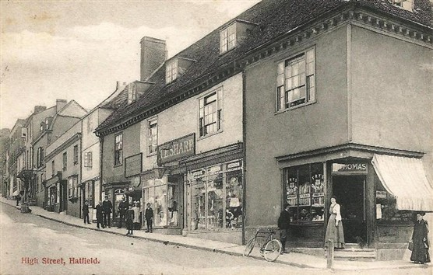
Fore Street, Old Hatfield (Source: http://www.ourhatfield.org.uk)

4. Projects Outline
This year the work, for the 3rd consecutive year, will focus on the historical area of Old Hatfield Town, as a site for research and design propositions. Old Hatfield consists partly of a medieval village built around Hatfield House; a 17th century palace, Hatfield House Old Palace, once the residence of Queen Elizabeth I; St Etheldreda church complex from 13th century, and a Tudor Church Hall. During its long history, the town grew to include buildings from the Edwardian and other historic period architecture. Old Hatfield continues to be inhabited today, including both shops and houses, as the Grade-II-listed (historically protected) neighbourhood we find today at the area between Hatfield Great Park and the Great Northern Road, in close proximity to Hatfield Railway station.
This year we will be designing an archive for the Old Town of Hatfield. An archive is, by definition, a structure that collects, stores, and organises objects and information with the purpose of making them available for consultation and study. Old Hatfield is a settlement whose story dates back to the Middle Ages and that developed during the Tudors in close relationship to the construction of Hatfield House and to the story of the aristocratic family inhabiting it. Today it is still a residential town and, increasingly, a tourist destination. Its future thus depends upon the interpretation, conservation and evolution of its historical identity. As such, our archive should operate in the divide between the memory of the past, the interpretation of the present and the desires for the future. We will work closely with the residents, who will share with us their stories, experiences and knowledge and these will constitute the base of the archive. The archive will be defined by the collection of objects, photographs, textures, drawings, videos, and models that you will record, collect and produce in your wanders across the town, in the conversations with the residents, in the careful observation of the architectural and urban elements, and, above all, in the representation and design activities.

5. Studios, Modules and Projects
This Project Brief is related to two Modules – Architectural Design Studio 1 and Design Skills 1 – that will run during the entire academic year and across Semester A and Semester B. The two modules are intended to complement each other. Each student is assigned to a Studio, which is a student group lead by one tutor. The activities are organised in three consequential projects, Project 1 (Sem.A), Project 2 (Sem A + Sem B) and Project 3 (Sem. B). For each project you will receive an extended brief with tasks, deliverables and specific bibliography/references.

Project 1 – Old and new OBJECTS in Old Hatfield - (October-November, Week 10-17)
The aim of P1 is to familiarise with the town and to explore media techniques (drawing, photograph, and model-making). You will be asked to collect or buy an object in Old Hatfield while engaging with the residents in a series of tours. The object will be drawn, photographed, scaled, displaced in different contexts, and, eventually, it will be the base of a design exercise. In P1 you will be split in three studios, each led by a different tutor; however the brief, outcomes and deliverables will be the same for the whole class.
Project 2 - The ARCHITECTURE of Archiving - (December-April, Week 18-31)
Architecture can transform the relationship of things to its surroundings and you will be experimenting along this idea. You will be given a site to design a building hosting the archive of Old Hatfield. This will be a sort of Cabinet of Curiosities of the 21st century able to embody an aspect of the identity of Old Hatfield that you will select and investigate. While collecting and exhibiting objects and information from the history and the present of Old Hatfield, the archive will act as a laboratory of discussion and ideas for the future of the local community of residents. The subject and the object of the archive are up to you (what does the archive contain? what is its purpose?), as well as its degree of accessibility to residents and visitors (who is the target of the archive?). Each building will include at least a room for storing and one for displaying the selected objects and information. The designated area for the building is the triangular site located at the cross between Fore Street, Salisbury Square, and Broadway Street. The formal definition of the building must respond to the existing condition of this site.
In P2 you will be split in three studios, each led by a different tutor who will develop a specific approach.
- Real Fictions - Led by Alvaro Velasco
The aim of this group’s work will be to gather memories, as well as the opinions and expectations of the residents with regards to the upcoming changes and life of the town.
- Dilemmas of Interiority - Led by Elena Palacios
The aim of this group’s work will be to study the buildings, their exterior and interior features, catalogue their typologies and historic features.
- From Fore Street and back - Led by Sabrina Puddu
The aim of this group’s work will be to study the urban spaces, streetscapes and landscape of public spaces in Old Hartfield.

Project 3 – The portfolio, the BOITE’ and the exhibition – (April-May, Week 32-42)
The aim of P3 is to learn how to order, archive and then exhibit your own personal work. It includes the project of a portable ‘Boîte-en-valise’ that, at the end of semester B, will be displayed in an exhibition organised with the residents of Old Hatfield.
Between 1935-1941, artist Marcel Duchamp built a ‘portable’ monograph of the work he had done until that time. He reproduced and miniaturized his own work and stored it inside a small suitcase. Like Duchamp, you will design and build your own ‘Boîte-en-valise’ to collect and organise the edited and improved work of the previous projects (P1+P2).
In P3 you will be split in three studios, each led by a different tutor; however the brief, outcomes and deliverables will be the same for the whole class.
The Heritage Hub community project: Old Hatfield – The latest transformation
Old Hatfield ca. 1930 (source: Digimap)
The current plan for Old Hatfield is to design new buildings as well as refurbish the existing buildings around Salisbury Square which will accommodate a modern lifestyle, new shops and commercial activities. The design challenge is to create a strong link between the existing structures and character of Old Hatfield and the new vision for the neighbourhood. The historical buildings, landmarks and public spaces are a crucial part of this, ensuring the continuity of the architectural complex.
‘The preservation of architectural detail and use of muted colours are essential ingredients for success. Given careful thought, Salisbury Square can become a place where people aspire to meet, shop and live, a place that becomes a joy to visit. It is the small features that reflect the heritage of Hatfield and the lives of its people that contribute most to a feeling of delight and wellbeing.’ – Old Hatfield Charette
At key points during the academic year (dates and location to be confirmed), the tutor groups will be working on-site in Old Hatfield, documenting and presenting their work to the local community. The project is a joint effort between the University of Hertfordshire, the Welwyn-Hatfield Council, the Old Hatfield Residents Association and Hatfield House.
6. Dates Summary
Architectural Design Studio 1 + Design Skills 1
Studio Day: Thursday 10am – 6pm, Room: AB147

Week | Day | Programme | Live Project | Lectures
Semester A
Week 09 T-1 | 28/09/17 | Induction
Week 10 T-2 | 05/10/17 | Sponge Exercise
Week 11 T-3 | 12/10/17 | Project 1: Old and New Objects in Old Hatfield | Live Project 1 | Launch P1 + Project Brief
Week 12 T-4 | 19/10/17 | Project 1: Drawing in class |  | Orthographic Drawing
Week 13 T-5 | 26/10/17 | Project 1: Drawing in class
Week 14 T-6 | 02/11/17 | Project 1: pin-up + Design Exercise
Week 15 T-7 | 09/11/17 | Project 1: Photo-shooting |  | PhotoShop
Week 16 T-8 | 16/11/17 | Independent Study Week |  | [use this week to catch up]
Week 17 T-9 | 25/11/17 | Project 1: Final Crit | Live Project 2
Week 18 T-10 | 30/11/17 | Project 2: The Architecture of Archiving |  | Launch P2 + Model Making
Week 19 T-11 | 07/12/17 | Project 2: Massing Exercise |  | Lecture on precedents
Week 20 T-12 | 14/12/17 | Project 2: Derive | Live Project 3 | AutoCad 1
Week 21 | 21/12/17 | Student Vacation
Week 22 | 28/12/17 | Student Vacation
Week 23 | 04/01/18 | Project 2: Individual tutorials
Week 24 | 11/01/18 | Project 2: Interim Crit
Semester B
Week 25 | 18/01/18 | Project 2: Archive Programme |  | AutoCad 2
Week 26 | 25/01/18 | Project 2: Archive Programme |  | Lecture on precedents
Week 27 | 01/02/18 | Project 2: Pin-up | Live Project 4
Week 28 | 08/02/18 | Check tutor’s extended brief |  | Lecture on precedents
Week 29 | 15/02/18 | Check tutor’s extended brief
Week 30 | 22/02/18 | Check tutor’s extended brief
Week 31 | 01/03/18 | Project 2: Final Crit
Week 32 | 08/03/18 | Independent Study Week
Week 33 | 15/03/18 | Study Trip
Week 34 | 22/03/18 | Project 3: The Portfolio, the Valise and the Exhibition |  | Launch P3  Review P1 + P2 work
Week 35 | 29/03/18 | Project 3: Review P1 + P2 material | Live Project 5
Week 36 | 05/04/18 | Student Vacation
Week 37 | 12/04/18 | Student Vacation
Week 38 | 19/04/18 | Project 3: Portfolio tutorial
Week 39 | 26/04/18 | Final submission
Week 40 | 03/05/18 | Exhibition + P3 Box | Live Project 6
Week 41 | 10/05/18 | Assessment (no class)
Week 42 | 17/05/18 | Assessment (no class)

Note: Please note the teaching schedule may change according to the academic progress of the student cohort

7. Submission Requirements

You will be assessed on the base of your portfolio (the ordered and edited collection of the materials elaborated in P1, P2, P3 and including drawings, photos, texts, and models), of your graphic and oral communication skills (as shown in the drawings, photos, models, but also in pin-ups, presentations, and exhibitions), of your capacity to develop an argument/design idea and on the accuracy of your research (as recorded in your sketchbook and in the other materials).

A detailed list of deliverables will be given in the extended briefs of each Project.

8. Assessment
The following is a list of what you will submit for final assessment, as final portfolio submission at the end of each semester. Note also the interim presentation dates in the weekly schedule.
There are two types of Assessment for each module, one Formative Assessment (cumulative, not final, an indicative mark may be given) and one Summative Assessment (final mark for the modules is given).
- Formative Assessment (Project 1) Week 14 – Thursday 2 November 2017
- Formative Assessment (Project 1) Week 17 – Thursday 25 November 2017
- Formative Assessment (Project 2) Week 24 – Thursday 11 January 2018
- Formative Assessment (Project 2) Week 31 – Thursday 1 March 2018
Final Portfolio Presentation & Submission for Summative Assessment on
Sem. B: Thursday 26 April 2018, 10am in Room AB147
Final Exhibition and P3 Box submission
Sem. B: Thursday 3 May 2018, location and time to be confirmed
For more information on the modules’ Learning Outcomes and Assessment criteria refer to the Module Guide(s) available on StudyNet.
9. Equipment
Logbook with notes
Please try to keep your logbook organised: take notes about what you hear, see, discuss and think for each session, clearly marking with date and place. Part of the logbook will be scanned (and eventually elaborated with Photoshop) and included in the final portfolio. The logbook is part of the submission requirements.

Laptop
You will need to have at least Autocad, Adobe Photoshop, Adobe Acrobat, Adobe InDesign, and Microsoft Word installed in your laptop. The School also has computer facilities (CAD suites) with the recommended software.

Notebook, pens, marker etc.
You will need to sketch your live impressions and ideas in class or in the place you are working at your project and you will also need to produce technical drawings. Make sure to have a varied range of pencils, markers (i.e. Pantone), pens, rulers, compass, a set of triangles 45°/90° 30°/60°, and different sizes of notebooks (A2, A3, A4…) as convenient. A list of material will be provided in the extended briefs of P1, P2, and P3.

Physical models
You will make models using materials, such as gypsum, wood, concrete, steel etc. Please be prepared to purchase these materials ahead of time and bring them to the class. A list of material will be provided in the extended briefs of P1, P2, and P3.

Photographic equipment
You will be asked to take photos of the site and of your work. You will need a camera and a tripod (these can be borrowed from the school)

10. Indicative Reading List
Architecture: Form, Space and Order (1979). Francis D.K. Ching,–, Van Nostrand Reinhold, New York,
Architectural Drawing (2014). David Dernie, London: Laurence King
Architectural Modelmaking (2014). Nick Dunn, London: Laurence King
Architecture: An Introduction (2010) Geoffrey Makstutis, London: Laurence King
Reading Architecture: A Visual Lexicon (2012). Owen Hopkins, London: Laurence King
Analysing Architecture (1997) Simon Unwin, London: Routledge
Exercises in Architecture: Learning to Think as an Architect (2013). Simon Unwin, London: Taylor & Francis
Architecture: Form, Space and Order (1979), Francis D.K. Ching, Van Nostrand Reinhold, New York.
Lessons for Students in Architecture (2001) Hertzberger, H. and M. van Vlijmen., 010 Publishers
Twenty-Five Buildings Every Architect Should Understand (2015). Simon Unwin, London: Routledge
The list is indicative, non-obligatory to purchase, a more detailed list with books from the library is available on the Canvas module pages.

Plagiarism Advice:
You must not engage in plagiarism when completing your coursework as it is a form of deception. It is deliberately or carelessly passing off another’s design, written or oral work as yours. If you engage in it, or allow others to copy your work, your work (and theirs) will attract a mark of zero pending investigation. Plagiarism includes copying the design (built or concept), ideas or research results of another without acknowledging the origin of the source. Acknowledging (crediting) a source requires an entry in your reference or bibliography. It also requires proper annotation and applies to both electronic and paper sources.

*** WORK HARD AND HAVE FUN ***

