GTR and Hatfield Station

GTR’s problems managing their trains are well known. Their problems managing Hatfield Station are perhaps less familiar. Three of these problems - The Long walk, the Missing Retail Units, and the Kiss and Drop issue - are described below with the action we believe GTR should take :

1.The Long Walk
Trains from London have stopped at the far end of Platform 3 since 2008, when we first complained (WBC article Feb 18th 2009). The reason we were given then was that drivers don’t know how long their train is, so the train could “stop short”. Carriages might then not be at the platform, and passengers could fall.
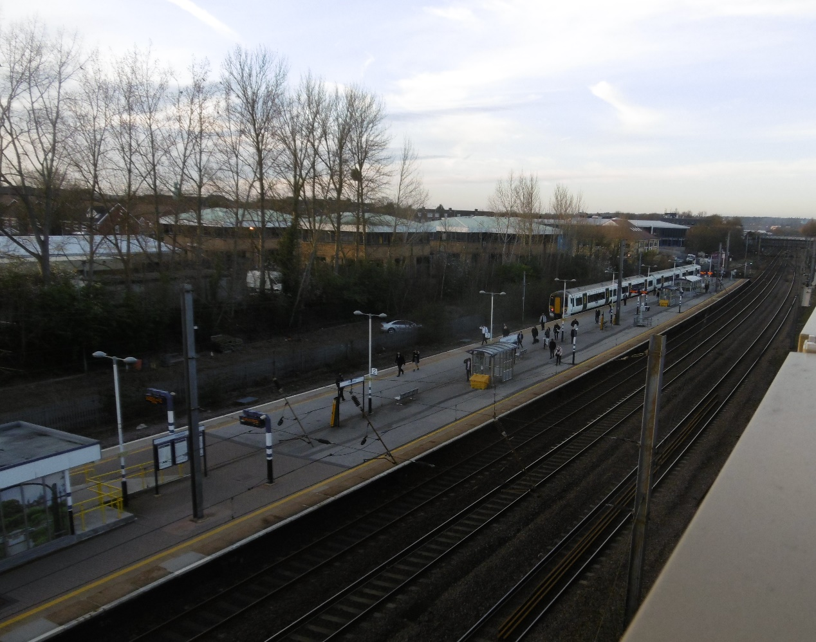 We have never been happy with this explanation, as it doesn’t apply in other stations, but we have been encouraged to wait for the arrival of new trains with Selective Door Operation (SDO). The carriages on the new trains sense the platform, and will prevent any doors from opening which are not at the platform. These trains are starting to arrive, but GTR are now saying that trains will continue to stop at the far end of the platform under the terms of an agreement with GTR: “The principle of the single stopping point at Hatfield will remain in place for the foreseeable future, as agreed with the ORR”.
We submitted a Freedom of Information request to Network Rail, and they replied “ORR are not aware of any such agreement and ORR does not play any part in deciding where stopping points are positioned”.
The reasons GTR give are not to be believed, and they show no concern for the inconvenience that this situation causes their customers.
In the 9 years we have been waiting for an answer to this problem we – GTR’s customers - have walked an unnecessary extra 144,000miles.
We ask GTR for their plan to return to the situation where trains stop where it is convenient for passengers

2. The missing Retail Units.
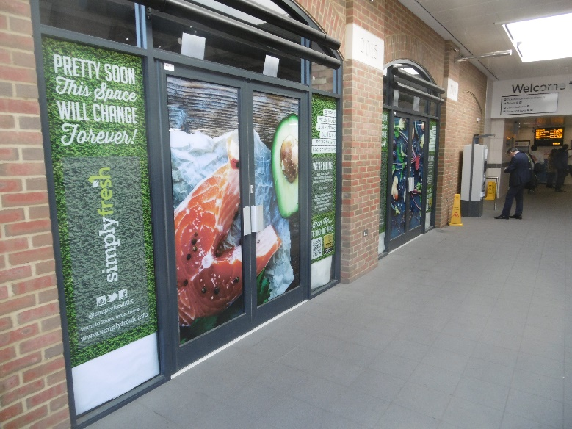
Hatfield Station was opened in 2015 and we were told on 29th January 2015 that “Work on shop fronts will begin soon, and it is hoped that at least some retail units will be open in 6 months”. There was considerable interest from potential retailers, but GTR seemed unable to respond to them or to make a decision, for reasons we have never been able to discover. In the event it took GTR almost two years to find Simply Fresh, who we think will be a very good occupier.
At the time of writing Simply Fresh are still held up awaiting Network Rail approval of their fit-out plans. Network Rail are in no hurry, it would appear.
We ask GTR to ask Network Rail to give priority to the approval of Simply Fresh’s fitout plans.

3. The “Kiss and Drop” issue.
The “kiss and drop” area in front of the station is very often overcrowded, and much of this has nothing to do with GTR. However the problem could be significantly reduced if people were to park in the /GTR Car Park, which is supposed to provide 20 minutes free parking.
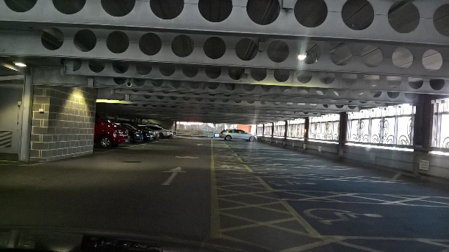
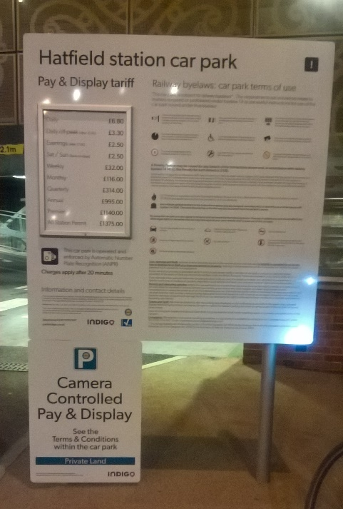
Ground floor parking – rarely used 20 minutes free signage – rarely seen

There is in fact a small sign advertising the free parking, buried in the signage where most people won’t see it, and anyone tempted to try their luck should know that there is rarely any space below the 6th floor to leave your car, or to meet anyone in the daytime. There are 14 Disabled Parking spaces on the Ground Floor – pictured - which are very rarely used, and we have written to GTR supporting parking in half of these spaces for up to 20 minutes but GTR appear to be unwilling or unable to persuade their subcontractor to co-operate.

We ask GTR to get their subcontractor Indigo to cooperate in allocating temporary parking spaces on the Ground Floor near the entrance

Chris Goward, Chair, OHRA

