Knotweed in Old Hatfield: cdg list of sites October 2016 update
- GCE/Res NHS building, on A1000 behind the car park with offshoots in Park Meadow and Park Mews - Significant reduction
- Res One separate front garden on Park meadow – not seen in 2016
- WHBC/Res Behind the Horse & Groom small site, disagreement about responsibility
- GCE Jacob’s ladder bottom: bank North (GCE) side & bottom steps – not seen in 2016
- WHBC/GCE Jacob’s ladder top & 25 Church St – serious action by GCE & WHBC
- GCE Around the Church Lane development barrier not seen 2016
- GCE/Res Park Close & Orchard patch treatment by GCE and residents
- Res Fore St significant reduction. Change of ownership

- A rubbish tip in the Park at the back of the East garden (unseen – to be removed from list
- Mill Green golf course (remote from Old Hatfield – to be removed from list).

- NHS building, on A1000 behind the car park with offshoots in Park Meadow including 33 Park Meadow back garden and Park Mews 30/8/2015
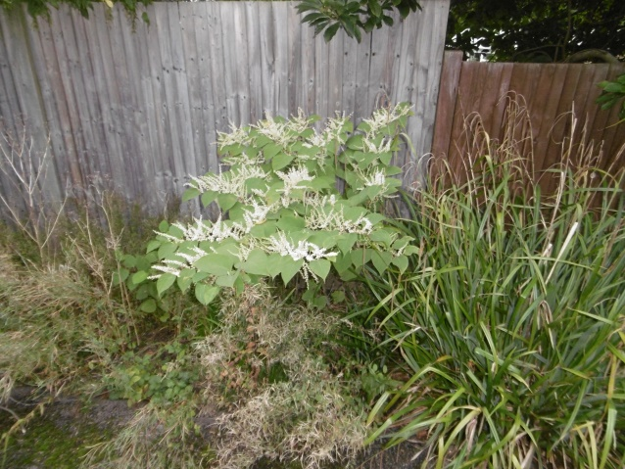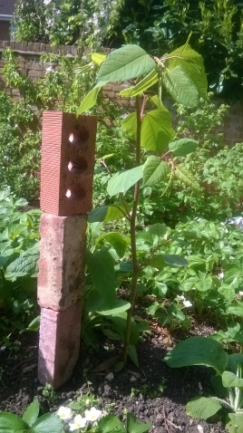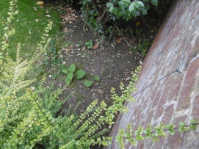
- One separate front garden 50 Park meadow 30/8/14
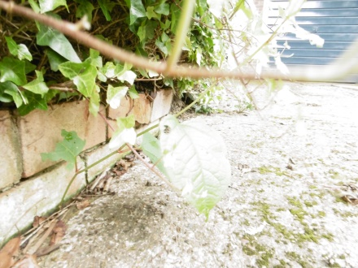

- Behind the Horse & Groom 2/8/15

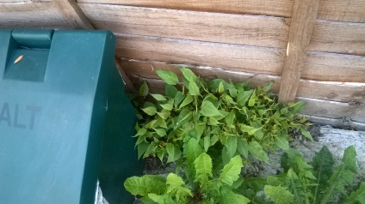
- Jacob’s ladder bottom: bank North (GCE) side & bottom steps (Herts Highways) 22/6/15 ie before restoration
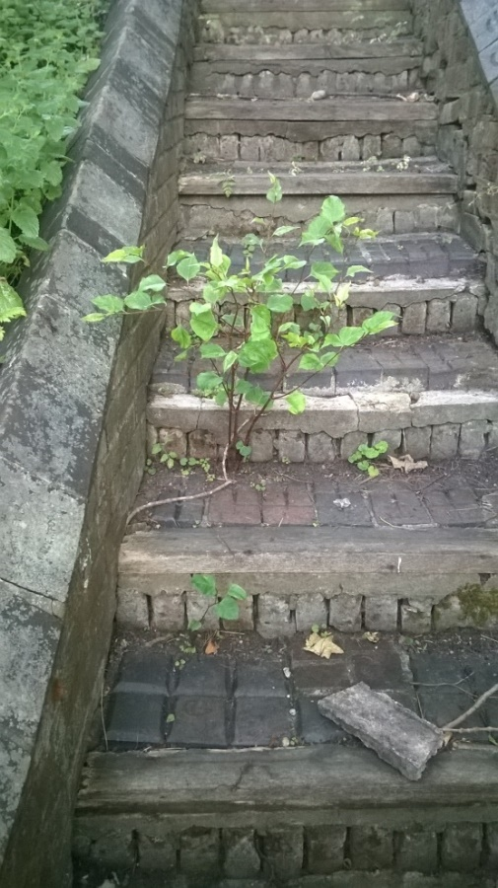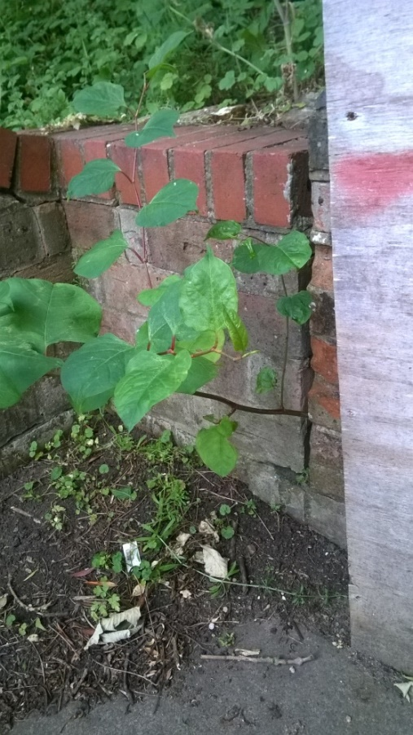
- Jacob’s ladder top & 25 Church St 3/9/2015 (both sides of fence)
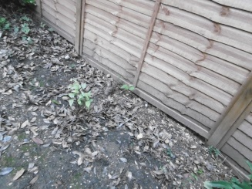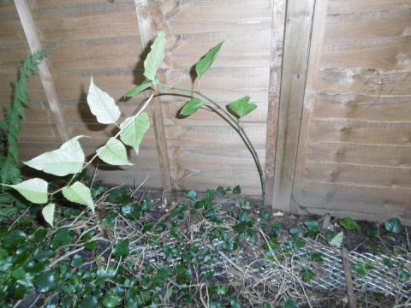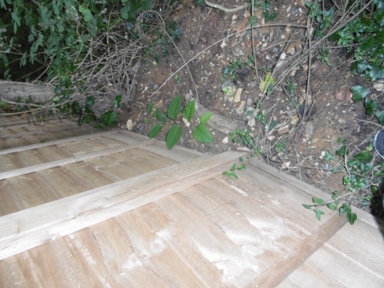
And June 2016 below:
And June 2016 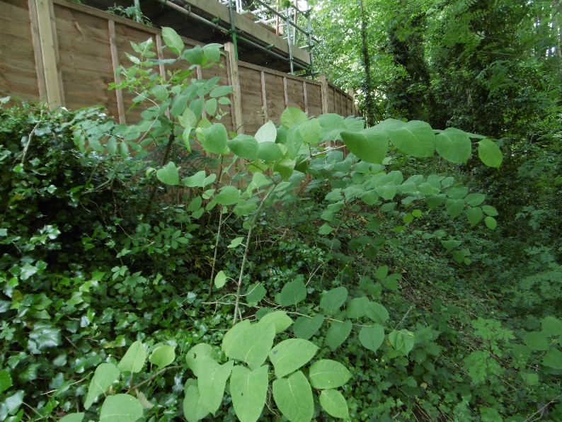

- Around the Church Lane development barrier 1/7/2014 (I’ve seen no sign of anything since then, but it’s a vulnerable area)

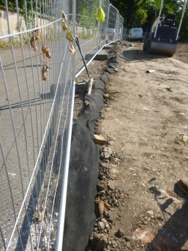

- Park Close & Orchard patch (Parles) 7/8/2015
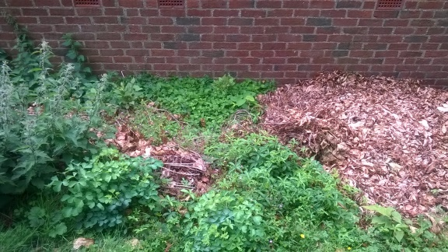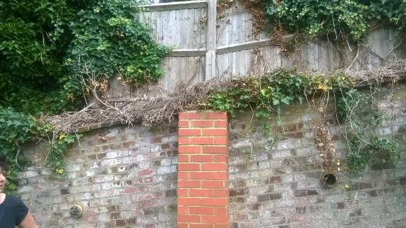
And May 2016 below
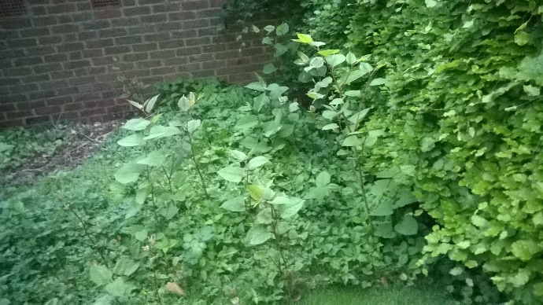
- Fore St 9 (Nan) 1/9/2015 (Left below) & June 2016 (Right)
